6th Grade Math
Supplies Needed:
- Wide-Rule Spiral Notebook
- 1” 3-Ring Binder w/ 5 dividers
- Paper
- Grading Pens
- Pencil

How can I connect with Mrs. Moore?
- Tamiesa.moore@Polk-fl.net
- (863) 499-2742 Be on time, on task, & prepared to learn EVERYDAY!
- lcmamoore.weebly.com
Personal electronics for EDUCATIONAL PURPOSES ONLY!
Be RESPONSIBLE for your own learning!

RESPECT the teacher, the classroom, and students!
Trash goes in the trashcan! #NOTYOURMAID
What if I’m Absent?
If you are absent you find the work you missed in class folder. You should copy your work into your agenda.
Students are 100% responsible for taking ownership of making up missed work. Refer to your agenda for the school policy for turning in late assignments due to an excused absence.

6th Grade FSA Info:
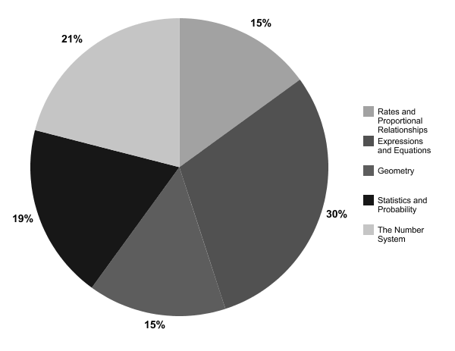

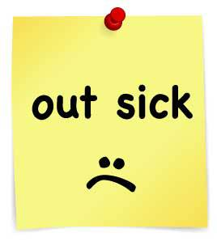

How will I be graded?
Formative(20%)
Assessments(80%) Formatives(20%)

Assessments can be in the form of tests, quizzes,
and projects. We will have assessments covering
two or three sections regularly. Summative
assessments will be given at the end of each unit.

Formative grades are homework, classwork,
Warm-ups, and participation.

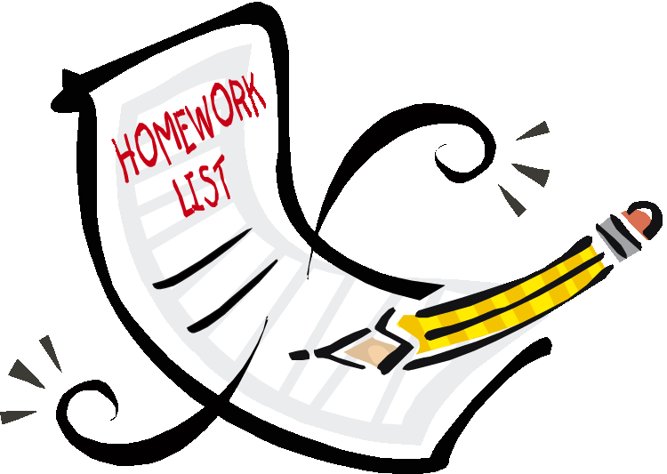

Homework:

How do I earn credit for homework?
- Give 100% effort-Attempt
ALL problems.
- SHOW YOUR PROCESS!

Warm Ups:
How do I earn credit for Warm Ups?
- Give 100% effort-Attempt
ALL problems.
- Attempt ALL Problems in PENCIL
- SHOW YOUR PROCESS!
- Check/correct with a correction PEN!
Math Binder:
What goes in my Math Binder?
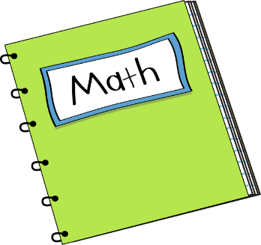
- Important Forms
- Warm-ups
- Practice Worksheets
- Assessments

Mrs. Moore’s Procedures:
- Entering (first 5 minutes):
- Remove all math materials from backpack and leave backpack in the back of the room.
- Quietly have a seat.
- Write in Agenda.
- Complete Warm up independently.
- Wait Quietly.
- During Instruction: You are expected to sit up and track the speaker at all times. It is also your responsibility to ask and answer questions.
- During collaboration/Group work: You are expected to remain on task at all times. All conversations should be only on the math topic being covered. You are expected to listen respectfully to classmates, as well as, be a contributing member to partner or group.
- End of Class: At the end of class, please remain in your seat. Once I have dismissed you, push in your chair and exit the classroom in a calm and appropriate manner.

Please Complete:
Please complete and return by 8/10/17
Student Name: __________________
Does your student have Internet Access at home: YES/NO
Parent Signature: _________________________
Parent Email: __________________________

