How Can I Help My Child 6th Grade Math?
- Encourage your child to take thorough notes and complete all homework assignments. All notebooks and old tests should be kept to use as review for throughout the course.
- Encourage your child to take advantage of online resources.
- Keep up with your child’s progress by periodically checking the parent portal for grades. A “Z” in the gradebook means that your child was absent and needs to make up that assignment. It is calculated as a zero until the work is completed.
What are the online resources for 6th Grade Math?
- www.lcmaknightsonline.com is the school website. Linking from there to “staff lists” to “faculty” and scrolling down to my name leads to my website. Clicking on my name will initialize an email to me and clicking on my subject area will link to my website.

- Online textbook- Go to www.polk-fl.net . Scroll to the bottom of the page into the gray section. Click on Classlink for students. Log in using student credentials. (be sure to include @mypolkschools.net). Click the icon that says myHRW.

- I will be using REMIND to send general announcements and reminders. Enrollment is optional and the directions are on the back of this handout.

- https://braingenie.ck12.org/ is a comprehensive Math and Science practice site providing practice and video lessons for a number of skills, using which you can learn, practice or quiz yourself. It facilitates adaptive learning and the element of gaming. (use of awards/badges) makes it more fun and competitive.
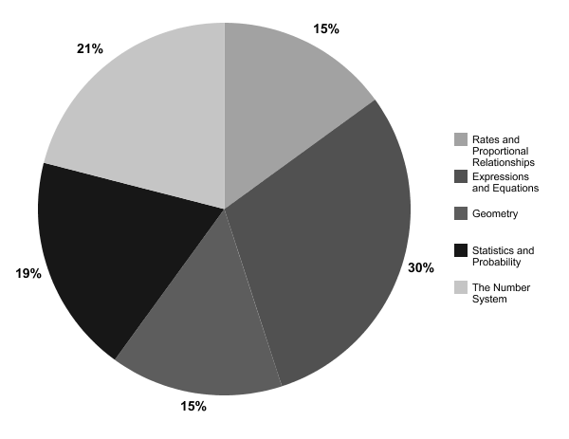
What are the skills tested on the 6th grade FSA?

Please contact me at anytime with questions or concerns at tamiesa.moore@polk-fl.net or at 499-2742.
Thank you for your support,
Tamiesa Moore

